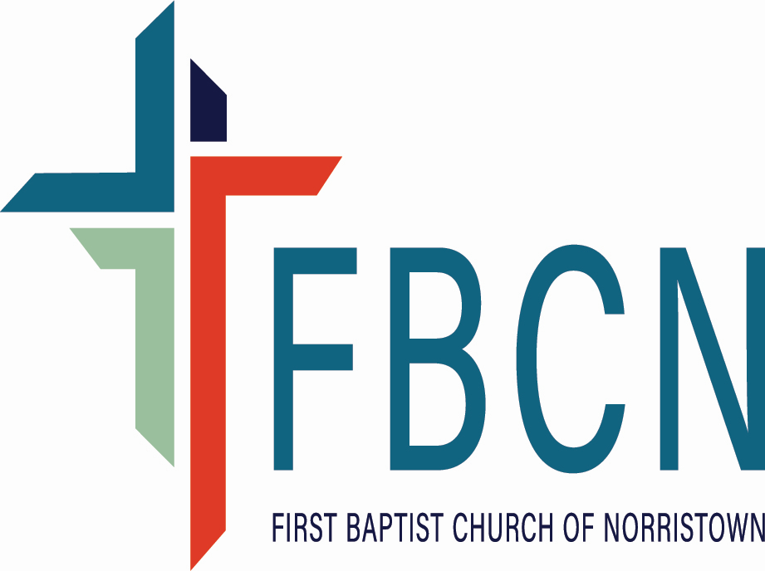

**www.fbcnorristown.org**

**445 Burnside Avenue, Norristown, PA 19403**

**610-539-7075**

**fbcnorr@verizon.net**

**Job Description: Part-Time Youth Director, 10 hours (flexible) per week**

**Ministry purpose:** Your role is to provide an environment that supports every student (6th-12th grade) in a continually growing relationship with Jesus Christ. Through spiritual and administrative leadership, the Youth Director will foster a strong educational program by building relationships with students, parents, teachers, and church members at the First Baptist Church of Norristown.

**Responsible to:** Pastor for day-to-day operations, Christian Education Subgroup for fulfilling the

responsibilities defined in the job description, defining goals, evaluation, and communication of

concerns related to the performance of the position.

**Job responsibilities:**

* Provide leadership and resource volunteers (this may include planning and participating in trainings at church or with another organization) to help move youth forward in their growth in faith and obedience to God
* Select and adapt biblically based, age-appropriate curriculum for youth of the church (ages 6th grade-12th grade)
* Help organize special outreach/fellowship events for youth
* Meet with other committees as necessary to plan special events
* Meet with the Pastor 1 time a month and the Christian Education Subgroup as often as they meet to collaboratively plan Christian Education for youth
* Report on your work at Church Business Meetings (3 times a year)
* Establish and maintain communications with church families and youth via phone, social media, social events, and in-person meetups
* Assist the Christian Education Subgroup in developing and balancing the Christian Education budget
* Enhance a relationship with our region of churches and the youth ministry regional events

**Current iteration of this role:**

* Participate in weekly worship services and special events related to youth ministries
* Schedule, resource, and lead Youth Group at least twice a month
* Recruit, schedule, and resource volunteers who help with Youth Group
* Lead in various roles upfront on Sunday morning during worship, such as Connections leader and special announcements
* Lead and organize a summer mission trip for the Youth Group (adjusted schedule during this month)
* Publicize upcoming and ongoing programs within the congregation and the community

**Qualifications:** This person will have a solid understanding of the foundations of Christian faith and a strong desire to nurture youth in the Christian faith. This person will generate new ideas and programs and value the team concept of ministry and accept suggestions from the Christian Education Subgroup.

* A vital relationship with Jesus Christ
* A degree, background, or experience in a relevant field of study
* A sense of call and a passion for working with youth and team members
* Good organizational, teaching, administration and computer/technology skills
* An understanding of adolescent and teen development and skill levels
* Strong written and verbal communication skills
* In accordance with the vision, philosophy of ministry, and commitments of FBCN
* Compliance with any necessary criminal background checks